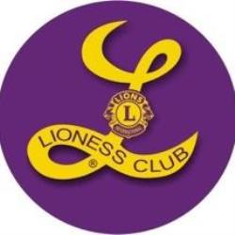

**Drums Lioness 12th Grade Service Award Criteria**

Lions Clubs International is the largest service club organization in the world. As part of this global organization, the Drums Lioness Lions Club proudly works to make a difference in the local community. This award will recognize exemplary student community service and leadership.

**Purpose**: The Drums Lioness Lions Club will honor a graduating 12th grade female student who exemplifies the Lions Club mission of kindness in action, leadership, and community service. This award is open to all female high school senior students with a Conyngham, Drums, or Sugarloaf address. The service award recipient will be chosen based on their community service and humanitarian leadership: the pillars on which the mission of the Lions Club International is built.

**Criteria**: Recipients should be continuing to higher education, enlisting in the military, or entering the workforce following graduation. Applicants should act as a leader among their peers and in the community. They should be active in community service (church, school, or community.) They should have a positive and encouraging attitude to everyone around them. In the event of a tie, the student with the higher GPA will receive the award.

**Recipients will:** be awarded an engraved plaque and a **$500** monetary award at the Senior awards ceremony at the recipients school.

**Deadline:** Applications must be received by midnight on **Friday, May 3rd, 2024**.

Please click [here](https://forms.gle/tUaitv7gvNCyb1839) to access the Google-based application

Please click [here](https://forms.office.com/r/XVcW5uds8M) to access the Microsoft-based application.

Please contact Jennifer Gerhard, [jgerhard@mmiprep.org](mailto:jgerhard@mmiprep.org) with any questions regarding the service award.